**QUEST BUREAU EXAMINATIONS BOARD**

# P.O.BOX 34836 KAMPALA

# P7 MOCK EXAMINATION 2024

# SOCIAL STUDIES

**Time allowed: 2 hours 15 minutes**

|  |  |  |  |  |  |  |  |  |  |  |  |
| --- | --- | --- | --- | --- | --- | --- | --- | --- | --- | --- | --- |
|  |  |  |  |  |  |  |  |  |  |  |  |

**Index No.**

**Candidate’s Name: ……………………………..……………………………………..**

**School Name: ………………………………….………………………………............**

**Read the following instructions carefully;**

1. This paper has two sections **A** and **B**

|  |  |  |
| --- | --- | --- |
| **FOR EXAMINERS’**  **USE ONLY** | | |
| **Qn. No.** | **Marks** | **EXR’s NO.** |
| **1-10** |  |  |
| **11-20** |  |  |
| **21-30** |  |  |
| **31-40** |  |  |
| **41-43** |  |  |
| **44-46** |  |  |
| **47-49** |  |  |
| **50-52** |  |  |
| **53-55** |  |  |
|  |  |  |
| **TOTAL** |  |  |

1. Answer all questions. All answers to both sections **A**

and **B** must be written in the spaces provided.

1. All answer must be written using a blue or black ball point – pen or ink.
2. Unnecessary changes of work may lead to loss of marks.
3. Any hand writing that cannot easily be read may lead to loss of marks.
4. Do not fill things in the boxes shown: “**for examiners’ Use only**”.

# SECTION A

***Section A carries “40” marks.***

* 1. Suggest **one** way you can protect yourself against kidnappers.

* 1. Why should a pilot look at a wind sock when landing an aircraft?

* 1. State **any one** importance of cultural leaders in the community.

* 1. How does the Kenyan government earn revenue from port Mombasa?

* 1. Which officer in the parliament carries the mace?

* 1. Name the European group the **MAUMAU** fighters were against.

* 1. How does river Nile help to show that northern Uganda is at a lower altitude than southern Uganda?

* 1. Which organ of a democratic government is responsible for organizing and conducting national elections?

* 1. Give **any one** advantage of barter trade.

* 1. Mention **one** way the East African Development Bank is useful to the member states of the East African Community.

* 1. Of recent, the Uganda government introduced the **PDM** program for wealth creation. Write **PDM** in full.

* 1. Give the reason why the Equator is marked 00.

_______________________________________________________________

_______________________________________________________________

* 1. Compare the Bakonjo to the Chagga in terms of settlement pattern.

* 1. How did the Buganda benefit from its early connections with the coastal Arabs?

_

* 1. Name **any one** Ocean currents that brings rainfall where it follows.

* 1. Name the ethnic group in Uganda that migrated from the horn of Africa.

* 1. What do we call the planting of trees in an area where they have ever existed?

* 1. Which colonial power ruled Rwanda after **World War I**?

* 1. How do swamps control floods in an area?

* 1. Suggest **one** way a country can attain a surplus budget.

* 1. Which constitution of Uganda restored traditional kingdoms?

* 1. Name the civic leader in the district responsible for children and family affairs.

* 1. What independence anniversary is Uganda expected celebrate on **9th October 2024**?

* 1. A town has an area of **50 sq.km** with **600** people per sq.km. Find the total population of the town.
  2. Why is it important for music lessons to be conducted in schools?

* 1. Mention **one** way how the Uganda government expresses national mourning.

* 1. What social service today did early man promote by taming the dog?

* 1. Why is Gregory Maloba still remembered in Uganda`s history?

* 1. Mention **one** way how smuggling makes local manufacturers lose market for their goods.

* 1. What source of government revenue does the Uganda government get from the judiciary arm?

* 1. State any one economic reason for the scramble for Africa.

* 1. What name is given to the system of trade where money is used as a medium of exchange?

* 1. How do police officers simplify the work of a magistrate?

* 1. Suggest **one** way the Uganda government can encourage people to pay taxes.

* 1. State the importance of recreation centers in our country.

## For each of the questions 36 – 40, answer either Christianity or Islam but not both in the same question.

* 1. **EITHER**: When is a sinner forgiven by God?

**OR:** When is a sinner forgiven by Allah?

* 1. **EITHER:** Who was the first prophet in the Bible?

**OR:** Who was the first prophet in Islam?

* 1. **EITHER:** Mention the second most important commandment according to Christianity.

**OR:** Mention the second pillar in Islam.

* 1. **EITHER:** What is a sacrament according to Christianity?

**OR:** What is Miraj according to Islam?

* 1. **BOTH:** What type of authority is possessed by only God/ Allah?

# SECTION B

41. **(a)** Which group of people introduces iron smelting in Uganda?

* + 1. During which period was iron smelting introduced in East Africa?

* + 1. State **two** changes in the life of early man that were brought by the discovery of iron smelting.

## ii).

42. **(a)** What is smuggling?

1. State **any two** dangers of smuggling.

**i). ii).**

1. Which section of the URA is responsible for fighting smuggling?

_ _

## Use the map below to answer the questions that follow.

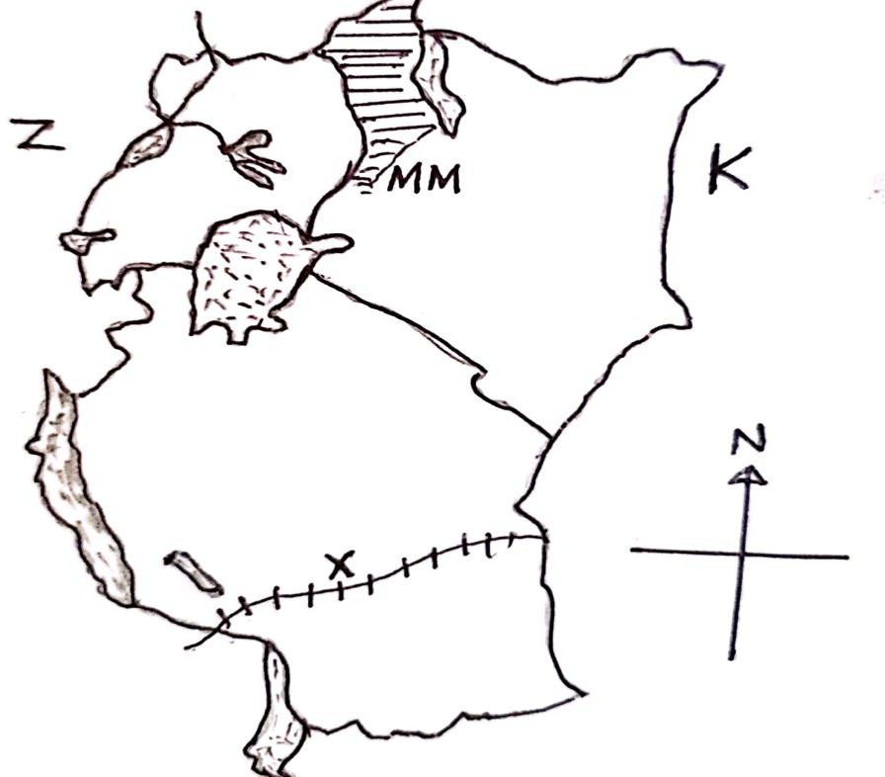

* 1. Which land locked country greatly benefits from the construction of railway line marked **X**?

_

* 1. State the major social problem currently facing country marked **K**.

_

* 1. Name the capital city of country marked **Z**.

_

* 1. Why was area marked **MM** transferred from Uganda to Kenya?

_

44. **(a)** State the importance of the following features to a map reader.

* + 1. Symbol :

* + 1. Scale:

(b) Draw the following features

|  |  |
| --- | --- |
| **Rift valley** | **Canal** |
|  |  |

45. **(a)** Who is a citizen?

1. State **any two** freedoms all Ugandan citizens enjoy.

**i).**



1. Mention **any one** factor that can lead to child labour.

46. **(a)** Which organization did the East African Community replace in **1967**?

1. State **any two** reasons for the collapse of the East African Community.

## i).

ii).

1. Name the supreme organ of the current East African Community.

47. **(a)** State **any two** examples of projects that one can start at home.

1. Mention **any two** benefits of having a project at home.
   1. _

ii)

## Use the map below to answer the questions that follow.

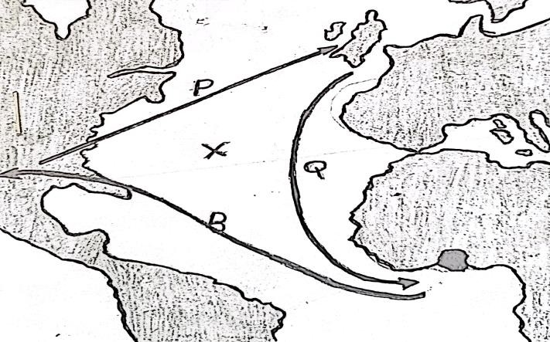

* 1. Name the trade illustrated by the arrows: **P**, **Q** and **R**.

* 1. How was the water body marked **X** important during the trade named **in (a)**

above?

* 1. Mention any one item of trade that was carried out through route shown by arrow **R**.

* 1. State **one** way how the above type of trade negatively affected Africa.

_ _

## Study the climatic table below and use it to answer the questions.

|  |  |  |  |  |  |  |  |  |  |  |  |  |
| --- | --- | --- | --- | --- | --- | --- | --- | --- | --- | --- | --- | --- |
| **MONTH** | **J** | **F** | **M** | **A** | **M** | **J** | **J** | **A** | **S** | **O** | **N** | **D** |
| **TEMP(0C)** | **30** | **31** | **31** | **31** | **30** | **29** | **28** | **25** | **29** | **29** | **29** | **30** |
| **R/FALL(mm)** | **250** | **350** | **325** | **300** | **213** | **25** | **25** | **100** | **275** | **375** | **380** | **200** |

* 1. Name the wettest month.

* 1. What is the annual temperature range?

* 1. What is the relationship between temperature and rainfall?

**(d).** What climatic region is shown in the table above?

50. **(a)** Define mass media.

1. Mention one example of mass media that requires literacy skill.

1. How do local manufacturers support mass media companies?

1. Name the body in Uganda that is responsible for the mass media services.

## For each of the questions 51-55 answer either Christianity or Islam but not both alternatives in a number.

1. **EITHER**
   1. Who composed the **Lord’s Prayer**?

* 1. State **any three** requests made in the **Lord`s prayer**.

**i).**



## OR.

1. Where do Muslims face when praying?

1. What name is given to the following prayers in Islam?
   1. Prayer performed in the early afternoon.

* 1. Congregational prayers on Friday.

* 1. Night prayers during the holy month of Ramadan

## EITHER

“Bring the whole tithe into the temple that there may be plenty of food there (**Malachi 3: 10**)

* 1. Who said the above words?

* 1. What is tithe?

* 1. Give any two reasons why Christians pay tithe.

## OR

Establish prayer and pay Zakat. Whatever good you send forth, for your own good. You will find them with Allah (surah Al Baqarah ayat 110)

(a). What is Zakat?

1. Mention **any one** Zakat recipient.

1. State **any two** reasons why Muslims should pay Zakat.
   1. _
   2. _

## Either

* 1. What do Christians remember on Easter Sunday?

* 1. Mention **two** ways how Christians honour Easter Sunday.
  2. Name the first person to see the empty tomb of Jesus Christ.

## OR

1. Why do Muslims celebrate Idd Adha?

1. Give **two** ways how Muslims honour the day of Idd adha?
   1. _
   2. _
2. Who was the mother of Ismil?

## Either

Match list **A** and **B.**

## List A list B

Garden of Gethsemane where Jesus ascended to heaven

Mount Olives Where Jesus was arrested from

Mount Tabor Where Jesus walked on water

Galilee Where Jesus transfiguration took

place

Garden of Gethsemane Mount. Olives Mount. Tabor _ Galilee

## OR

Match list **A** and **B**.

## LIST A LISTB

Mecca where prophet Musa was born

Medina Where Prophet Mohammed was born

Jerusalem Where Prophet Mohammed was buried

Misiri Where early Muslims face when praying

Mecca Medina Jerusalem Misiri

## FOR BOTH

* 1. What is divorce/ talaq.

__________________

* 1. State any two causes of divorce/ Talaq.

2. 1. Mention **any one** effect of divorce/ Talaq.